Class Diagram:
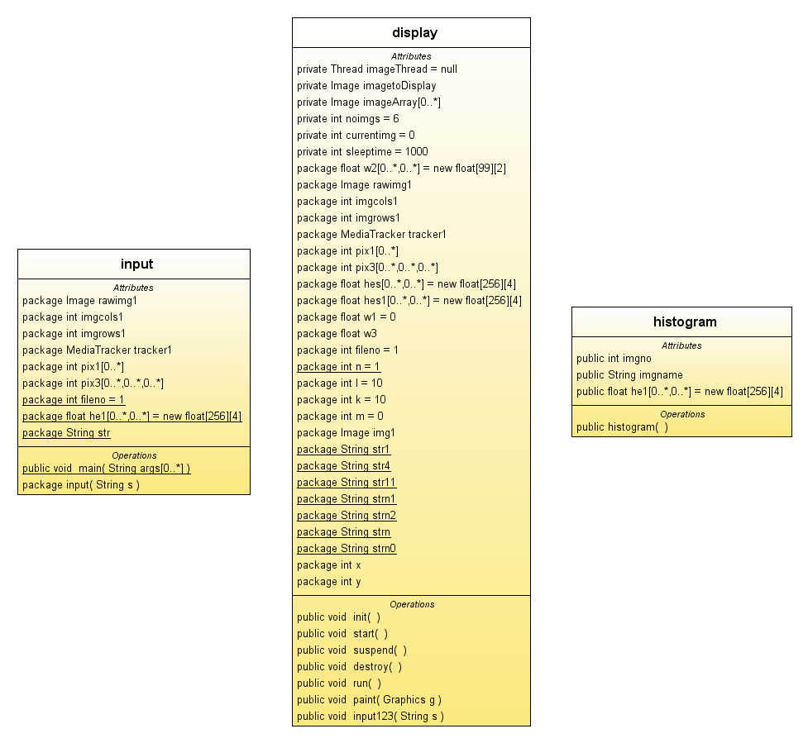

SYSTEM DESIGN

Compute
the
Histogram
Calculate the IRM
Distance
Image Archive
(Visual Content)
Extract
the
Color feature

Query
Image
Result of the Search

Figure 1

2.2DATA FLOW DIAGRAMS

Level 0

Retrieval
System

Query
Image

Result Images

Figure 2

Level 1

Figure 3
Feature
Extraction
Match
And Retrieve
Images

Results
User Query
Our Archive

Level 2

Calculate
IRM
Distance
Query Image
Extract
RGB
Content
Calculate
the
Histogram
Retrieve
the5 best matches
Display
Results
Our Archive
Figure 4

2.3 USE CASE DIAGRAM

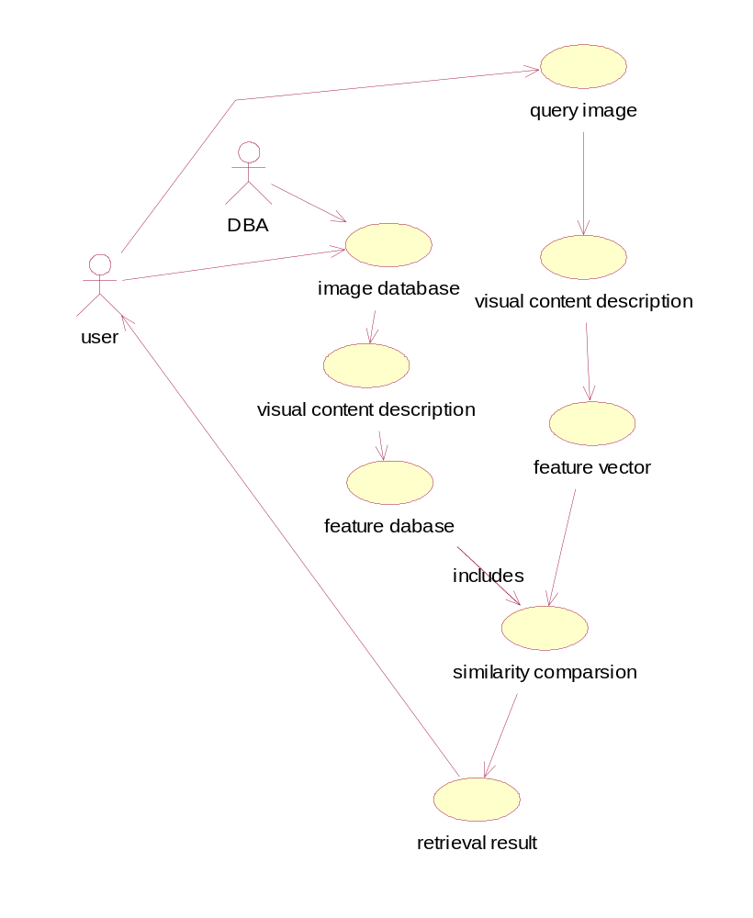

Sequence Diagram:
User:
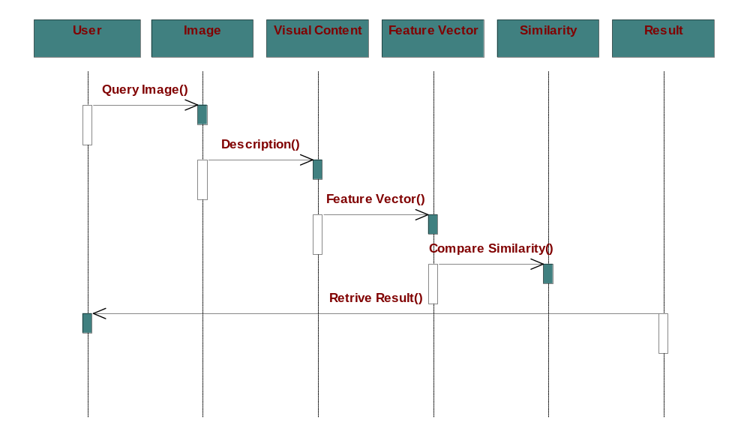

DBA:
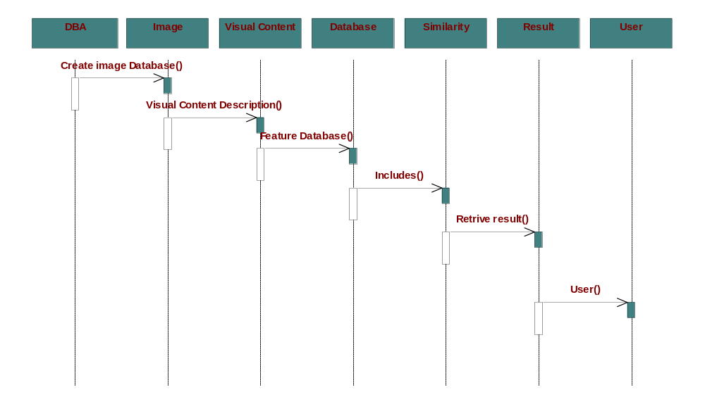

Collaboration Diagram:
User:
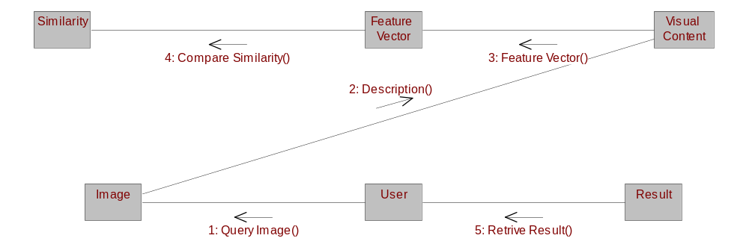

DBA:
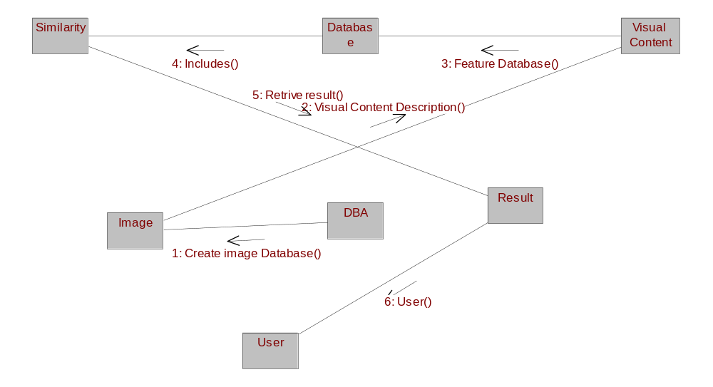

Component Diagram:
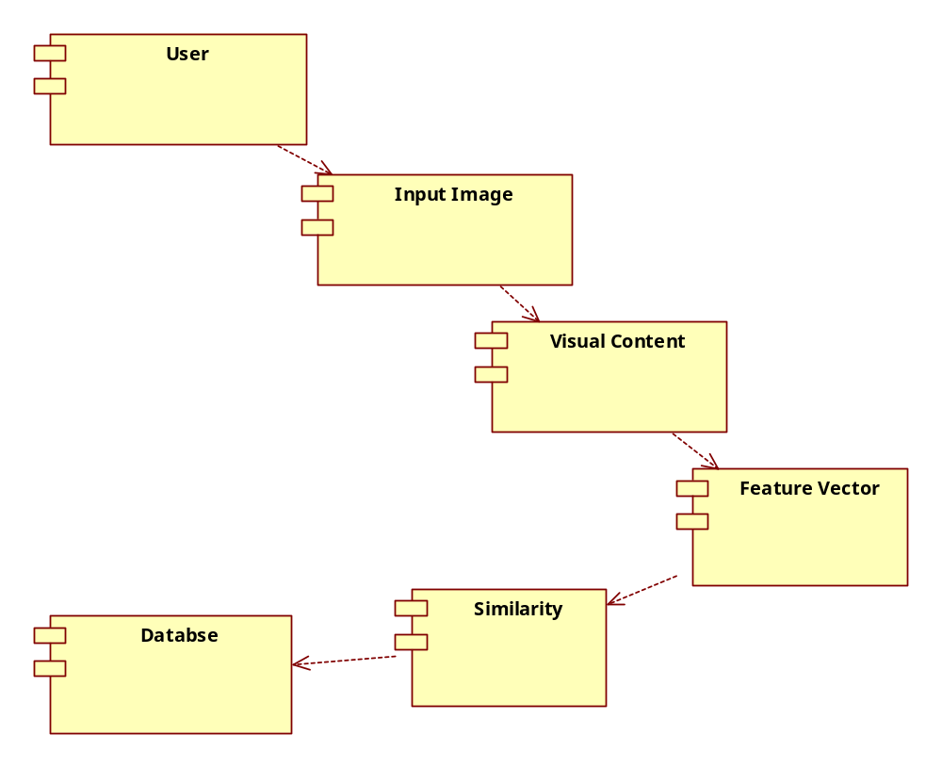

Deployment Diagram:
